**Project Name:** GrocerWala

**Project Members:**

|  |  |
| --- | --- |
| **PRN No.** | **Name** |
| **220343120047** | **Shweth Kenkre** |
| **220343120107** | **Tesjas Shrirao** |
| **220343120049** | **Akshay Khole** |
| **220343120053** | **Lakshya Pareek** |

**Introduction of Project:**

Online General Store is a site where you can order grocery from your near by general store sitting at home.

**Objective and Scope of Project:**

This site allows you to select the grocery which are available at the

general store sitting at home. You can collect it from the General Store.

This site will show you the available options of food and household supplies at the store and allows you to place an order at store at a time

Summary of your particular order will be sent and you can pay the bill by QR or Phone number of the general store or by Cash at time of picking up the grocery.

As soon as the marketer pack the grocery the notification will sent on your register number or on site from which the person placed the order.

As the Marketer will have less customers to deal with and will be able to work faster comparatively and the customer wont have to wait for very long time at the general store . And the customer will be able to select whatever they want without wasting time for waiting in queues.

**Modification and improvement over the existing Implementation:**

Present State

After implementation of project

**(Note – Please make a list or highlight the main points which you are going to implement)**

**Project Plan:**

No. of User’s and Modules

**Users-** The person or organization that will use the project's product are 2. The Admin and the Customer

The Admins will manage the inventory ,orders and billing. Customers

will order and pay.

**Modules** - Module is a logical separation of a functionality within a

project.

Modules for online general store portal:

1.Customer management- A database where the Customer history of order will be kept successfully.

2.Billing - The billing will send the bill to the customer and customer can pay at the time of picking up the grocery .

3.Product management-This product management will be done by the

admins .

**Technology:**

Frontend- JavaScript/Jquery/React

Backend-Web Java

Database-Mysql

**Roles and Responsibilities:**

|  |  |  |
| --- | --- | --- |
| **Roles And Responsibilities** | | |
| 1 | Role | Back-End Developer |
| Member Name | **Shweth Kenkre** |
| PRN No | 220343120047 |
| Description | Will be handling the backend development. |
| 2 | Role | Front-End Developer |
| Member Name | **Tejas Shrirao** |
| PRN No | 220343120107 |
| Description | Will be handling the designing of the page |
| 3 | Role | Back-End Developer |
| Member Name | **Akhsay Kohle** |
| PRN No | 220343120049 |
| Description | Will be handling the backend development. |
| 4 | Role | Database Manager |
| Member Name | **Laksya Pareek** |
| PRN No | 220343120053 |
| Description | Will be handling the Database and relationships |

**ERD / Database Tables:**

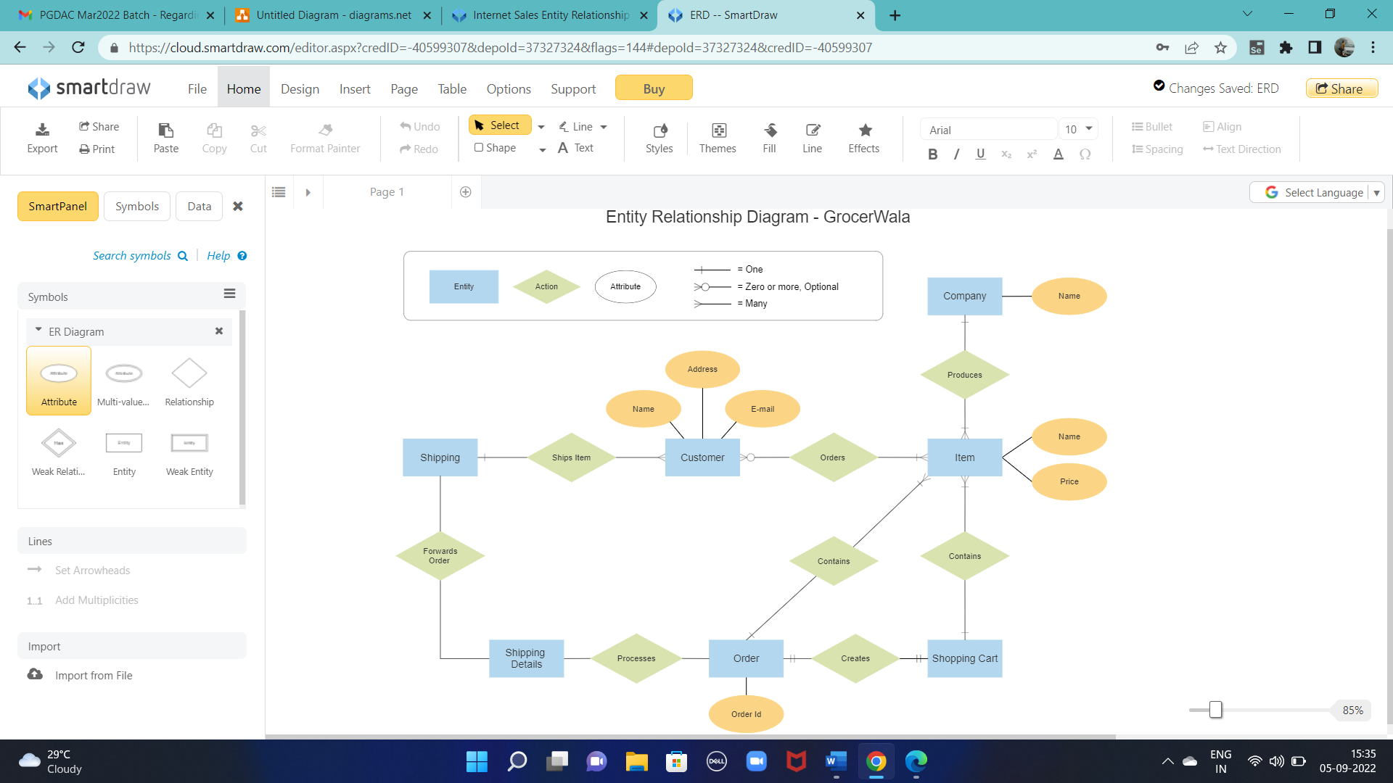

**Future Scope:**

Add UPI, Net Banking and Credit Card payments.

Grocerwala is a site where you can order grocery from your near by general store sitting at home. This site allows you to select the grocery which are available at the general store sitting at home. You can collect it from the General Store. This site will show you the available options of food and household supplies at the store and allows you to place an order at store at a time. Summary of your particular order will be sent and you can pay the bill by QR or Phone number of the general store or by Cash at time of picking up the grocery. As soon as the marketer pack the grocery the notification will sent on your register number or on site from which the person placed the order. As the Marketer will have less customers to deal with and will be able to work faster comparatively and the customer wont have to wait for very long time at the general store . And the customer will be able to select whatever they want without wasting time for waiting in queues.